**Ping from one machine to the other. If it fails, use ifconfig to ensure the IP addresses are configured correctly.**

**Machine 1: Windows**

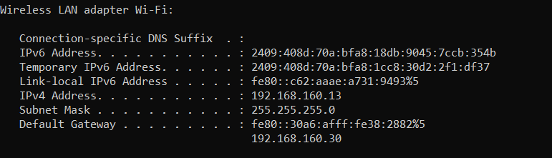

**Machine 2: Linux**

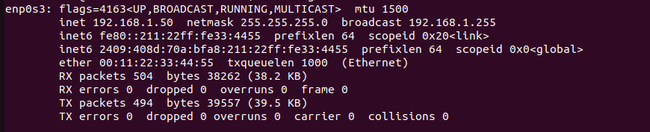

**Pinging Machine1 🡪 Machine 2 Fails:**

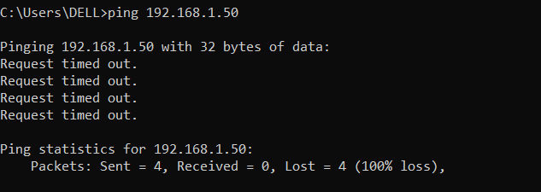

**Fixing Configuration:**

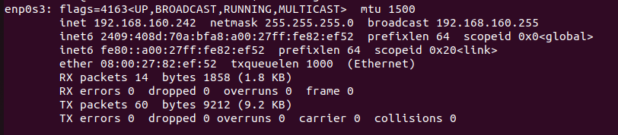

**Pinging is Successful:**

**Machine1 🡪 Machine2**

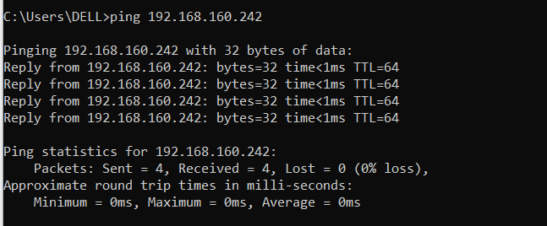

**Observation:**

* Ping from Windows to Linux initially failed, indicating a connectivity or configuration issue.
* Checked IP configuration using ifconfig, ensuring both machines had the correct IP addresses.
* Fixed the configuration issue, possibly by setting the correct IP, subnet, and enabling network interfaces.
* Ping was successful after the fix, confirming proper network communication between Windows and Linux.